1. Client :

<https://www.drivedigitally.com/hwhavenew/edit-task-step-1/WL1A36XRGF>

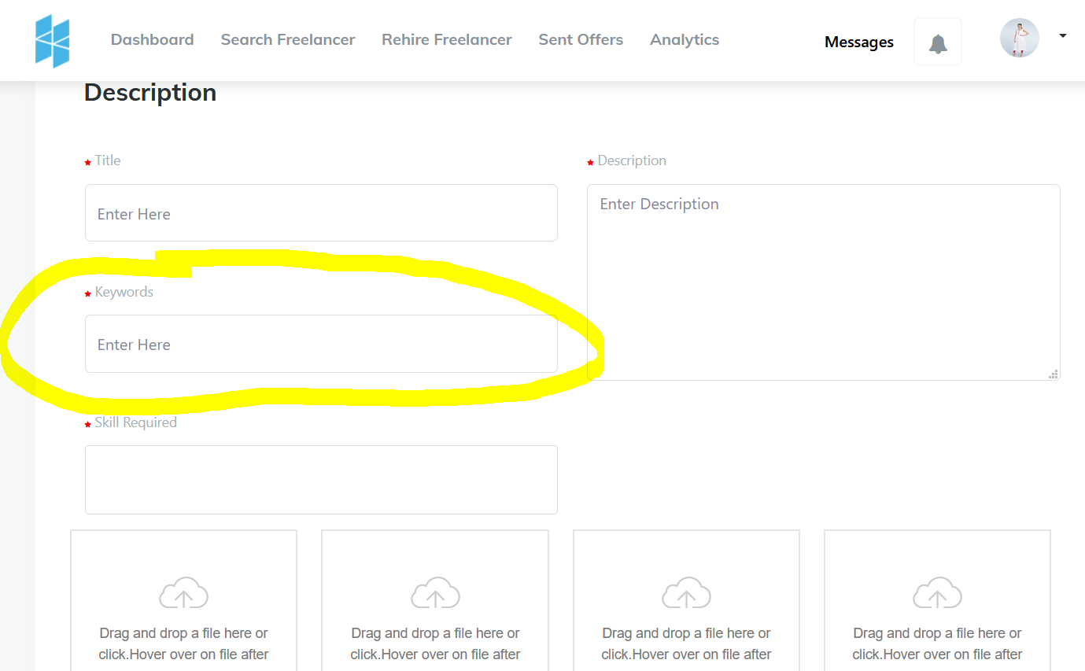

Insert this keywords section in edit page , as well as below page. <https://www.drivedigitally.com/hwhavenew/task-details/WL1A36XRGF>

<https://www.drivedigitally.com/hwhavenew/task-details/WL1A36XRGF>

Image Name : Job_Details_Hire_n_Work

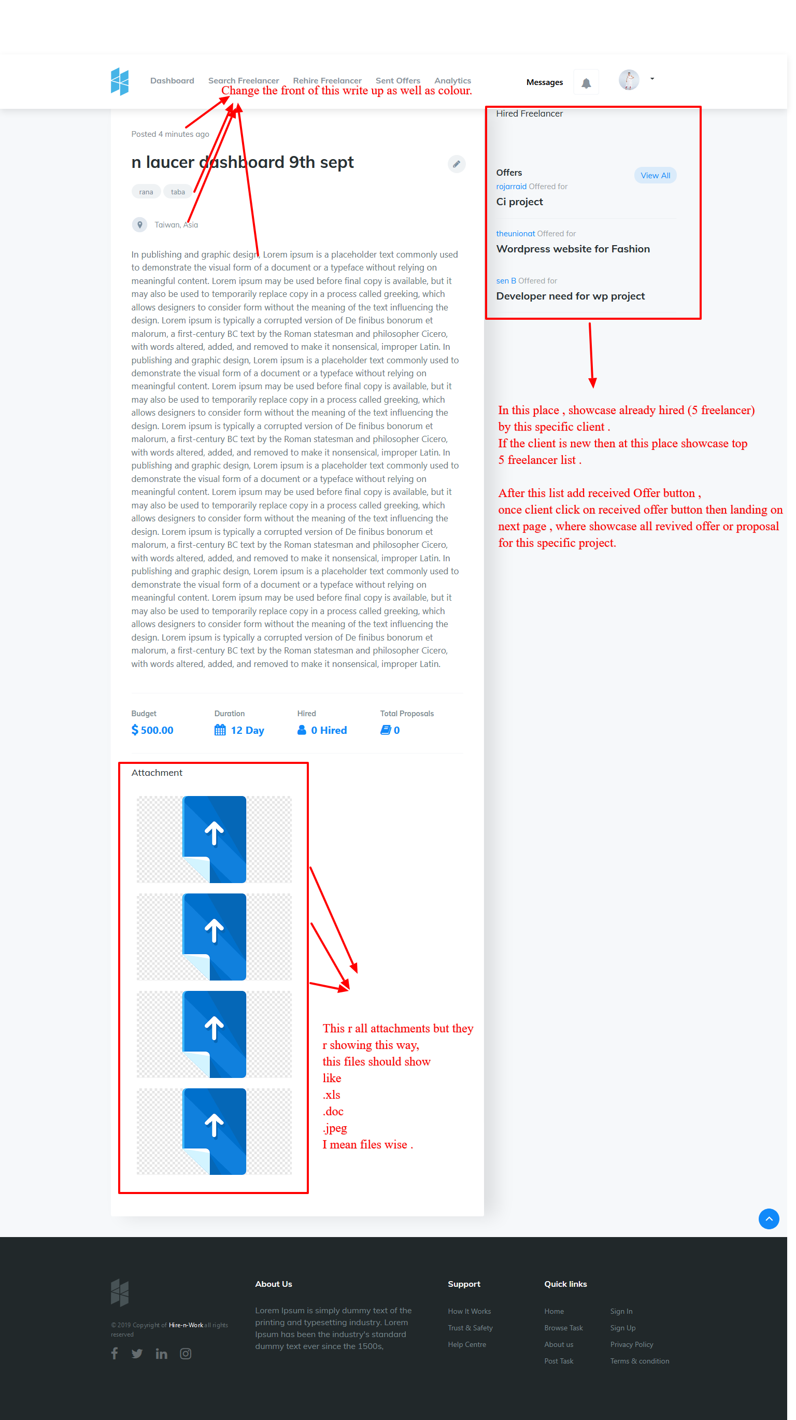

1. Freelancer

<https://www.drivedigitally.com/hwhavenew/key-list>

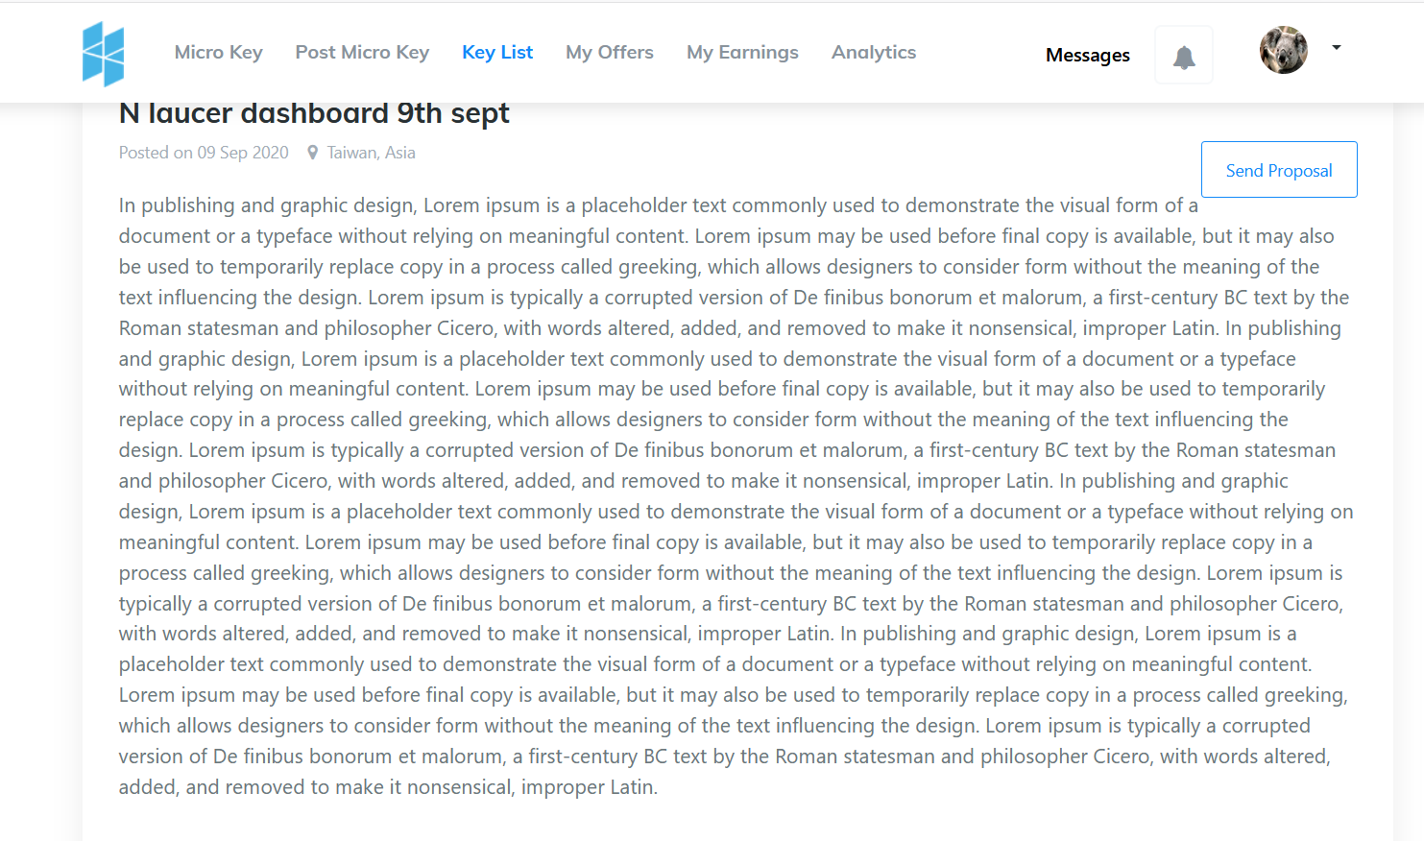

Check the design & fix it .

3.